HD 106515A

HD 106515A is a 0.97 M☉, G5 star1. HD106515 is a double star system and HD 106515B was identified as a 0.89 M☉, G5 star with a projected binary separation of 310 au1. Based on 46 RV CORALIE measurements obtained between 1999 and 2012, a study performed in 2013 (hereafter M13)1 reported a LPGP signal with a period of 3630 ± 12 days, a minimum mass of 9.61 ± 0.14 MJup and an eccentricity of 0.572 ± 0.011. The CH survey reported a LPGP signal with properties close to those reported in the M13 study.

In the present study, the M13’s dataset[1] was considered. DPASS and MCMC (1000 walkers and 300000 iterations) were used to fit the data. The properties of HD 106515Ab are close to those reported in the CH survey. The fits are shown in Fig 1, and the corner plot in Fig 2, and the results summarized in Table 1.

Note that, recently, combining RV and Hipparcos/Gaia absolute astrometry data, a study performed in 20212 were able to estimate the orbital inclination, and thus the true mass, of HD 106515Ab. They found a period of days, an eccentricity of 0.571 ± 0.012, an inclination of ° or °, and a mass of MJup.

Conclusion: The properties found in the CH survey for HD 106515Ab are confirmed. The combination of RV with astrometry shows that HD 106515Ab is in fact a brown dwarf.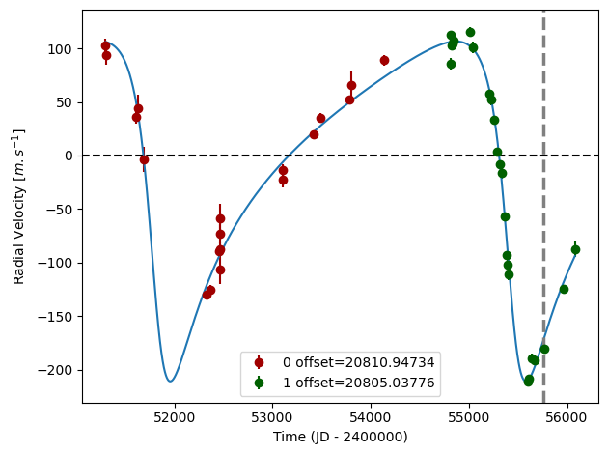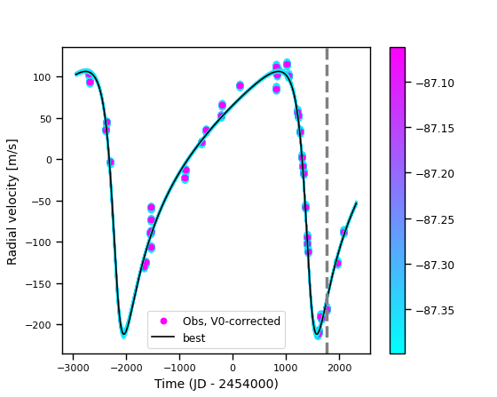

Figure 1: Left: fit of the HD 106515A RV with DPASS. Red - C98, green - C07. The blue curve shows the best fit. Right: fit of the HD 106515A RV using MCMC. The black curve shows the best fit. The colorbar corresponds to the log-likelihood of the fits. The gray dotted line indicates the end of the CH survey.

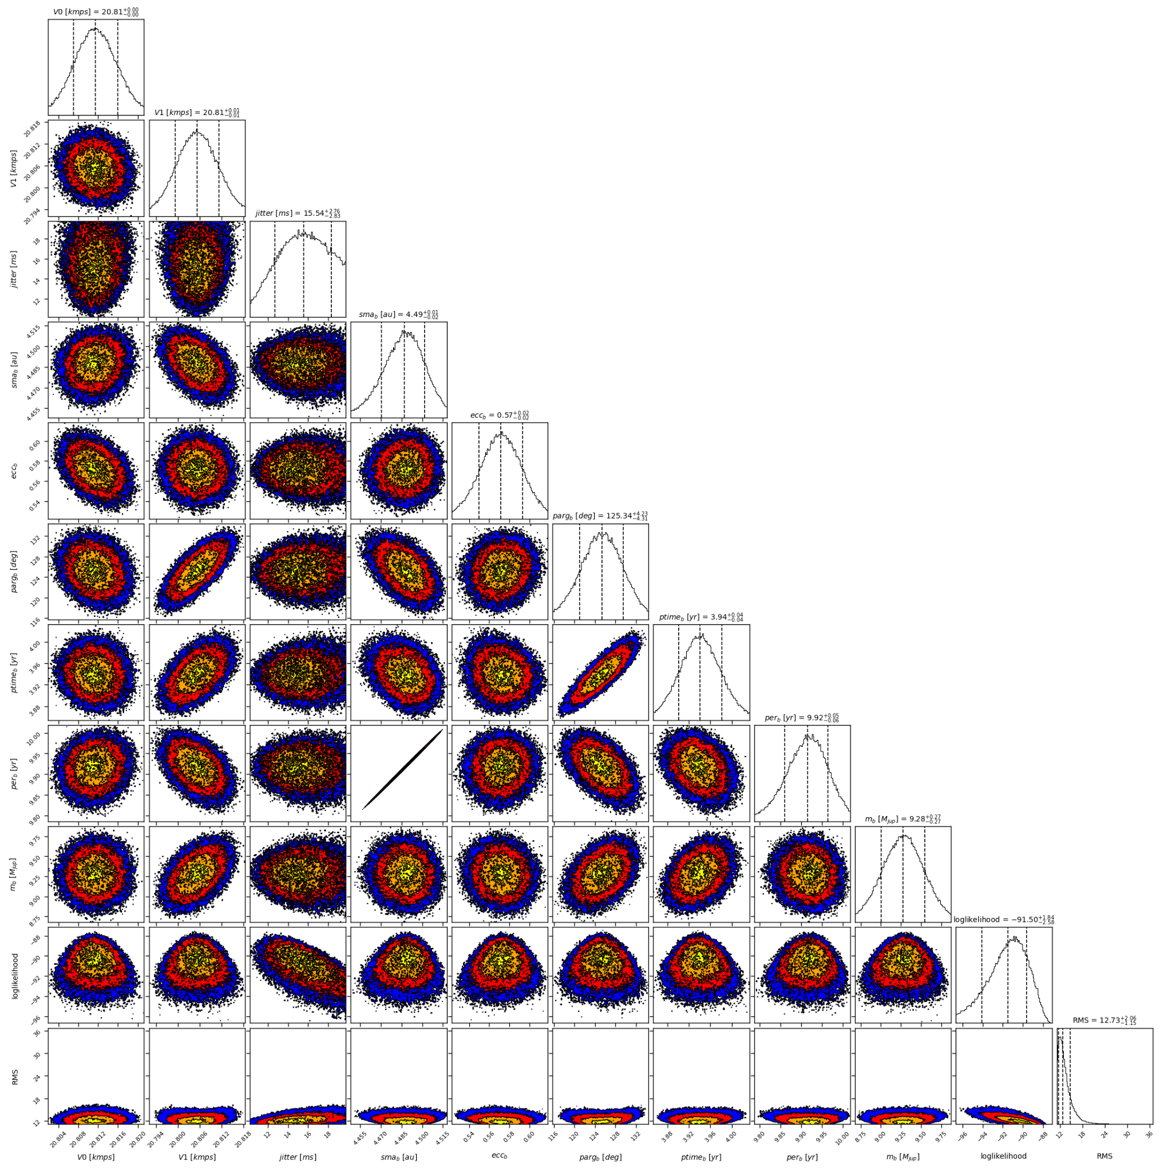

Figure 2: Corner plot of posteriors for the one-planet model MCMC fit of HD 106515A RV data.

| Parameter | Priors | | Posteriors | | CH survey |
| --- | --- | --- | --- | --- | --- |
|  | DPASS | MCMC | DPASS | MCMC |  |
| *a* (au) | [0,100] | [1,10] | 4.6 |  | 4.5 |
| Msin(i) (MJup) | [0,100] | [0.5,20] | 9.8 | 9.3 ± 0.3 | 10.5 |
| Eccentricity | [0,0.95] | [0,0.95] | 0.56 | 0.57 ± 0.02 | 0.5 |
| Instrumentals offsets (m/s) | [-60,60] | [20,22] | C98: 20.811  C07: 20.805 | C98:  C07: 20.805± 0.006 |  |
| Stellar jitter (m/s) | [0,40] | [0,40] | 11.7 | 15.5± 2.8 |  |
| Argument of periastron (°) | [0,360] | [0,360] | 124 | 125± 4 |  |
| Phase | [0,1] | [0,1] | 0.29 | 0.40 ± 0.01 |  |

Table 1: HD 106515A. Summary of priors and posteriors obtained with DPASS and MCMC, compared to the properties reported by the CH Survey.

References

1. Marmier, M. et al. The CORALIE survey for southern extrasolar planets XVII. New and updated long period and massive planets. *Astron. Astrophys*. 551, A90 (2013).
2. Li, Y. et al. Precise Masses and Orbits for Nine Radial-velocity Exoplanets. Astron. J. 162, 266 (2021).

1. The CORALIE data were not available on the CDS database; therefore, these data were recovered from DACE. Note that DACE provides 43 measurements obtained with CORALIE-98, i.e 3 less than the data used by M13 study1. Yet, the RV curve stays the same.